Facial recognition is a complex method of identifying or verifying the identity of an individual using their faces. Facial recognition systems are capable of identifying people in photos, videos, and in real-time. This method is a category of biometric security by using technology capable of running millions of deep and complex algorithms to classify facial features.

With the numerous amount adoption and usage in today’s society, several methods of facial recognition can be found depending on their specific uses. Facial recognition technology can be used in various way but in general operates in the similar matter as other complex machine learning methods. In a superficial and simple conclusion, the steps of facial recognition can be summarized into fragments of complex steps.

* Step 1: Face Detection
* Step 2: Face Analysis
* Step 3: Data Conversion
* Step 4: Comparison

To understand facial recognition, one must understand the process of image segmentation. One of the first step in image segmentation is locating the region of interest [ROI] within an image. The ROI is the location and coordinate of the person’s face within an image or video. This step can be ignored if the whole image is being classified as one entity in a perfect scenario. But since the facial recognition will include real life matters with multiple objects and/or people in the same image, many irregularities arises and henceforth regions of proposals must be identified and specified to run a pipeline able of multiclass classifications.

The way the facial algorithm works mimics that of a human brain to summarize it vaguely. When a person opens their eyes, the first step in to locate the location of that object which displays interest to the person. Afterwards, the person may identify this object or completely ignore it if the object or person does not offer any importance. But once aware of the presence of the object or person, we can easily make mental notes of its or their location in the 3D space.

For this project, two existing idea of methods were used in locating the coordinates of the faces in an image on behalf of faster speeds and quality search which is then heavily modified to account for the world we currently live in today where everyone is always wearing mask. The methods used were a deep learning method of Convolutional Neural Network (CNN) and a deep metric learning of Histogram of Oriented Gradients (HOG).

**Facial Detection**

The method of Histogram of Oriented Gradient (HOG) is a feature descriptor used to provide visual features of the contents in images, videos, algorithms, and application which produces descriptions like facial features that include color, shapes, textures, size, and fill. Its basic idea is that local object appearance and shape within an image can be described by distribution of intensity gradients or edge directions to simply represent the image by extracting useful information and not extraneous information that will prolong the process. In summary, this feature descriptor converts an image which consist of three channels into a feature vector with a length of n. In the case of the HOG feature descriptor, the input image is of size 64 x 128 x 3 and the output feature vector is of length 3780.

Once an image has been converted into a feature vector, it can then be used in tasks like image recognition and object detection. The feature vector produced by these algorithms when fed into an image classification algorithm like Support Vector Machine (SVM) produce stellar results.

In a HOG feature descriptor method, a distribution or histograms of directions of oriented gradients are used as features to locate the important features of the face. The derivative gradients of a face in an image shows large magnitude around the edges, corners, and many features of the face. With these distributions, we can easily create an algorithm that can extract the exact coordinate of a face.

To calculate a HOG descriptor of an image, a horizontal (x) and vertical (y) gradients are calculated using different filters of kernels. To achieve this, a Sobel operator with a kernel size of 1 is used in the image.

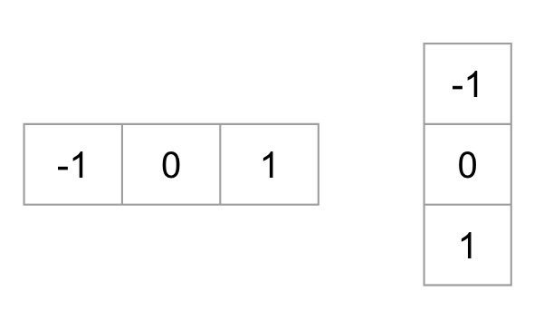

Sample Vertical & Horizontal Kernel used in HOG

Once the kernel is used to calculate the gradients of an image, the magnitude and direction of the gradients can be calculated using the following formula:

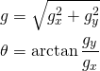

Gradient Magnitude & Direction Calculation

The next step to apply this method to an image is by dividing the image into small cells and calculate the histogram of gradients for each cell. The image is divided into “patches” of cells to provide a compact representation of the image to expedite the process. For example, an 8×8 image patch contains 8x8x3 = 192-pixel values. The gradient of this patch contains 2 values (magnitude and direction) per pixel which adds up to 8x8x2 = 128 numbers. These pixels in these 8x8 cells are then added up to create a 9-bin histogram. From here, the histogram is then normalized to remove the vector scale of an RGB color vector. Now that this histogram is normalized, instead of having 3 channels, we now have a histogram consisting of a 9x1 vector scale. Finally, once a HOG feature vector is calculated for the whole image, we can concatenate them all into one giant vector containing thousands of dimensional vectors of the image. If we visualize this process, a sample output can would be of one seen below.

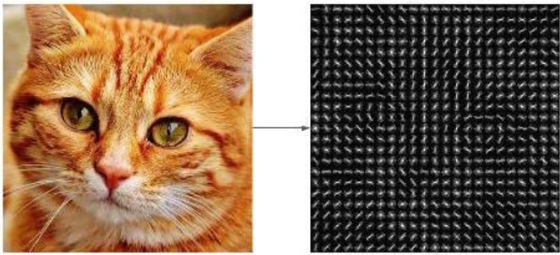

Input Image (Left) & Output Image (Right)

Gradient Magnitude & Direction Sample Visualization

In this case, instead of old image segmentation methods of outputting only a single label or coordinate of an object in an image, we are instead outputting a real-value feature vector that we can use to represent the basic structure of a face in a simple way. Finally, this method can be used to collectively generate a HOG face pattern generated from multiple facial images and is used to easily locate faces in any image.

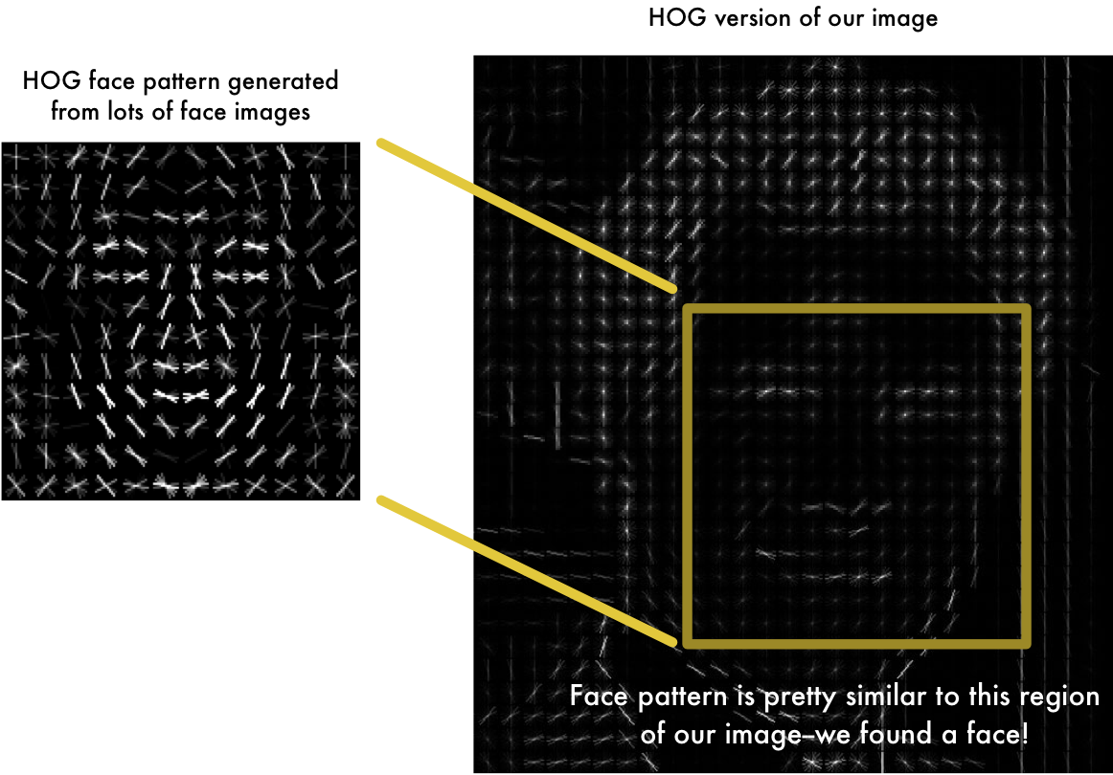

HOG Facial Pattern Technique

One of the problems in this method is the current direction required for a face to be facing in order for the algorithm to use this technique. The person must face towards the camera for the pattern to be similar or exact. To account for this, an algorithm called Face Landmark Estimation is used to warp each picture so that the small features of the face such as the eyes and the mouth are always in the sample place in the image. The basic idea is to transfer specific points of the existing face into “landmarks”. These landmarks capture the pattern calculated in whole face including all the small features of specific points on any faces.

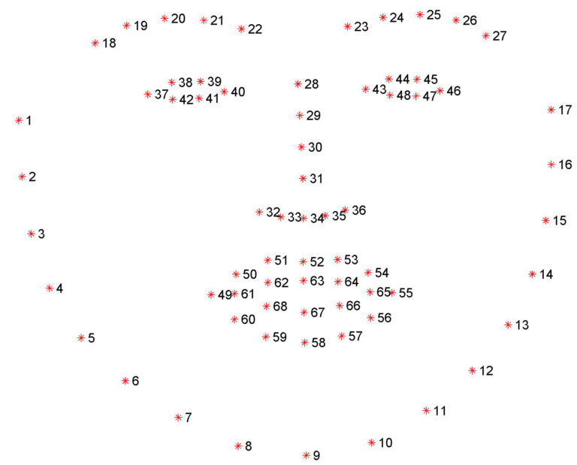

Facial Landmarks

Using this method, we can easily locate the features of the face and simply rotate, scale, and shear the image so that these features and centered as best as possible by using affine transformations without introducing any distortion which can cause misclassifications. This way, we can easily compare our facial embeddings no matter if the face is centered or facing a different direction.

Although locating a method of facial detection is accurate 98% of the time using the Histogram of Oriented Gradients (HOG), it can easily misclassify and sometimes not locate faces due to unaccounted circumstances. Due to its somewhat simplicity in classification, it can produce really fast results when locating the coordinates of facial features, but it may not work due to certain irregularities presented. To improvise and vastly improve the accuracy, a modified brute force method is used in conjunction to the faster method using a Region-based Convolutional Neural Network (RCNN).

The architecture of this RCNN consist of Felzenszwalb’s superpixel generation method to create a selective search algorithm. Old brute force image segmentation method consists of a “sliding window method” which takes a filter and runs it through every single pixel of an image and creates thousands of regions. As an image gets larger or filter gets smaller, this process all the sudden become really computationally expensive and takes a long time to execute on one image and the algorithm becomes sensitive to parameter choices. The benefits are that every single objects or items in an image can be classified without missing them.

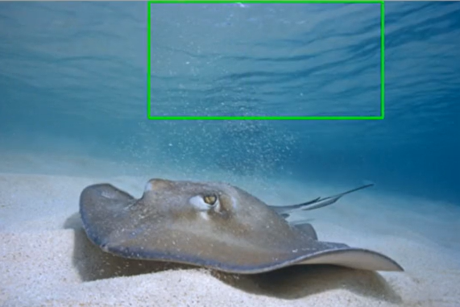 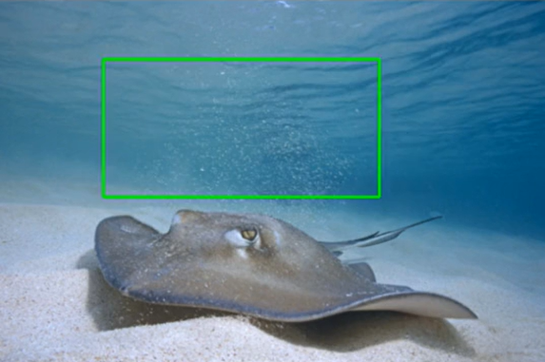 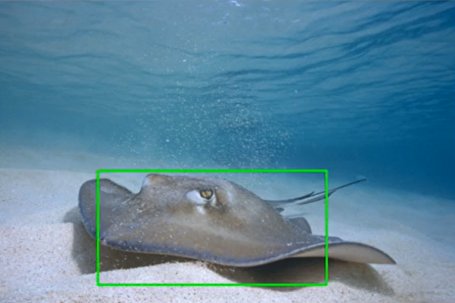

Three Sample Instance of Brute Force Method Using Sliding Window from Left to Right

Since this facial detection algorithm will be used in the real world where the speed of the system will be of great importance, the sliding window method must be avoided and hence why Felzenszwalb’s superpixel generation method is used. This selective search algorithm filters an image by utilizing a series of equation that divides an image based on color similarity, texture similarity, size similarity, and fill similarity. Regions of proposal candidates can then be created by using a merging equation to create single components.

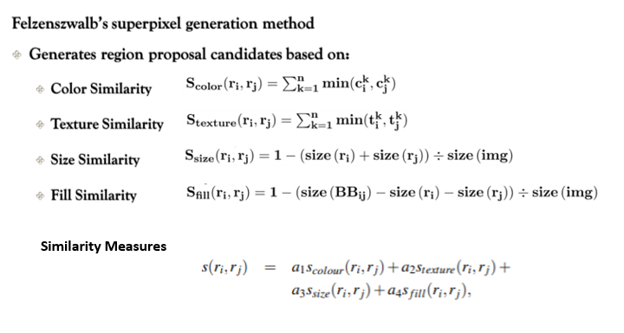

The algorithm pseudocode can be summarized as the following:

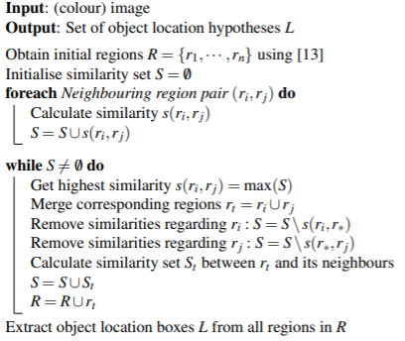

Hierarchical Grouping Algorithm

Using these series of equations, we only output regions of interest with actual objects within itself and not thousands of redundant and empty images.

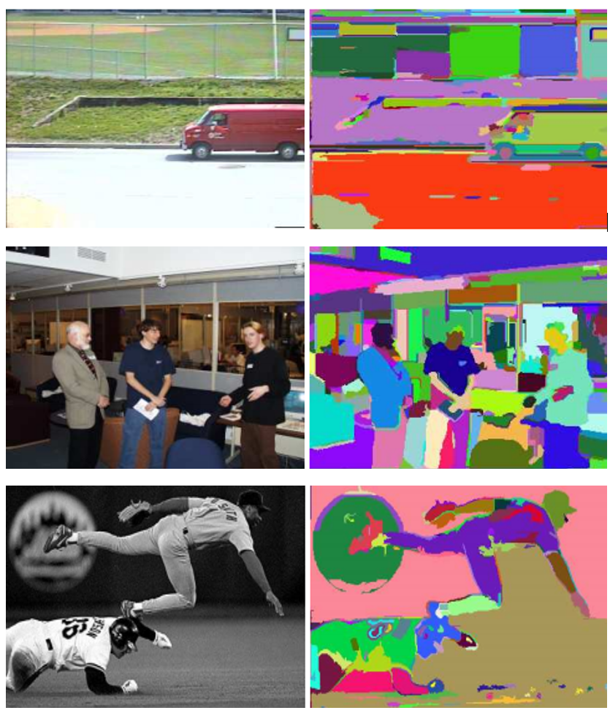

Sample Output using Felzenszwalb’s superpixel generation

The RCNN then utilized a ResNet50 machine learning network, which consist of predefined but untrained neural network with series of complicated features of convolutions, pooling, comparisons, and 50 dense layers which concludes to millions of parameters for the deep learning network to train with.

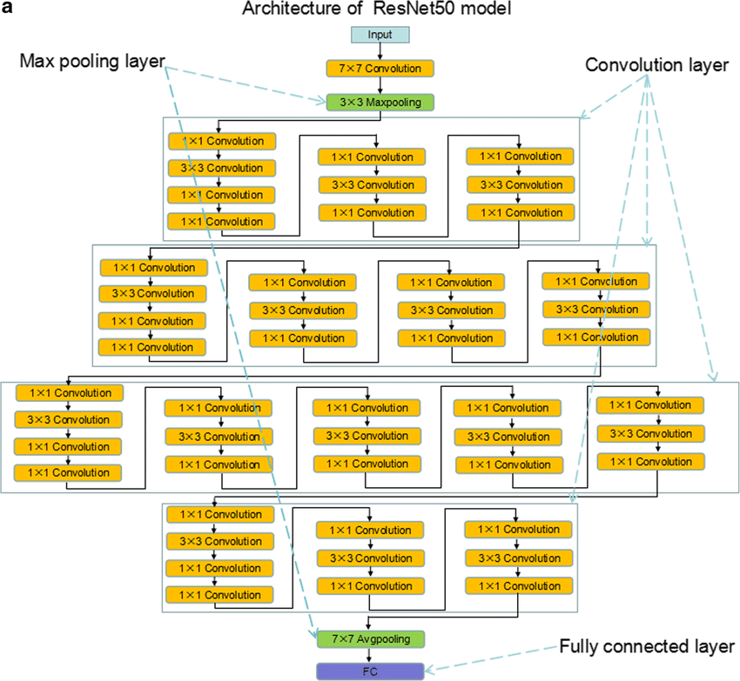

ResNet50 Model Architecture

Once these regions of interest are preprocessed through normalization, non-max suppression, and etc., the HOG facial pattern technique can then be applied to each regions of interest and extracts the exact coordinates if a face is located. Since a deep neural network is trained with millions of undefined parameters, the model can easily account for abnormalities and still detect facial features if necessary.

Using the RCNN method is more computationally expensive than the HOG method, although if proper equipment such as a GPU is utilized, this can be a difference in 1-2seconds. With these methods, we are now equipped with a faster computation and a quality search that can work in tandem together.

**Facial Recognition**

The facial recognition occurs after the given the face has been detected. But to do so, the pipeline must include pretrained weights of the faces being identified. Therefore, to have a fully functioning pipeline, the facial recognition pipeline must be able to load a pretrained weight from the model trainings.

1. Model Training

Model training includes the facial detection pipeline. After a face has been located with its coordinates. Either HOG or CNN must be applied to create weights from the given identities.

* HOG: Once a face is detected, it is then transformed into a 128 d-embedded key. The more data that is included in one’s facial identity, the more key can be related to this one person. Once 128 d-embedded keys have been developed, these are then saved as the pretrained weight used for classification. When a facial detection recognized a face in a new image, it will then use those 128 d-embedded keys of the new face and compares in to the face of the saved array keys.

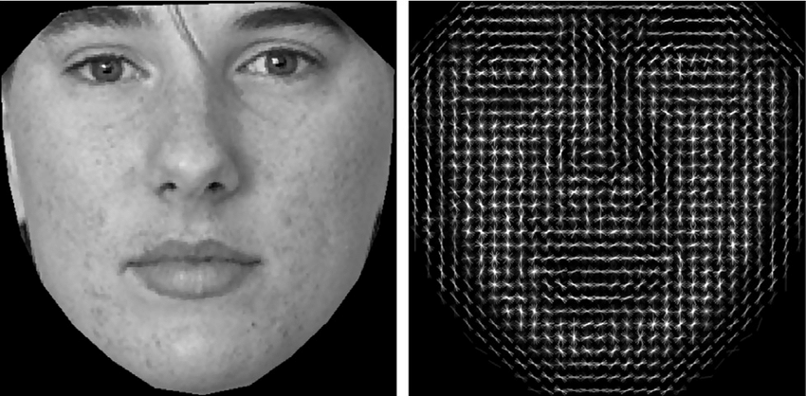

Key Formed from Histogram of Oriented Gradients

* RCNN: This neural network will be trained from the given training set to be compared to the new untrained images. This convolutional neural network is capable of creating its own neuron weights that can predict what its classifying. With many iterations and training, this model can be divided into multiple batches for GPU training using the CUDA architecture which speeds up the training process and identification process. The model can also be retrained with new images which allows the model to increase in accuracy in more time and data.

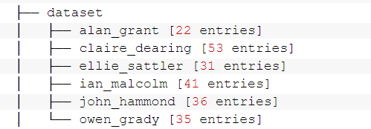

For this case, the models were trained with 218 images from the cast of the Jurassic Park.

1. Facial Recognition Pipeline

Once the weight has been created by either HOG or CNN methods, the pipeline can now identify facial features and compare new faces in the untrained image.

* First, the pipeline will consist of a facial detection algorithm to locate the new face in the new image that has never been trained on
* Then, the pipeline will simply iterate through the loaded weight to compare the new face to the labeled weights from either HOG or CNN
* Finally, if a match is found, it will return the label it matches. If not, it will return an unknown data.

The following images are outputs from both methods.

* The HOG method takes just about 1 second.
* The CNN Method takes just about 2-3 seconds with a GTX 1080 GPU, but takes about 42 seconds without a dedicated GPU and only utilizing a CPU

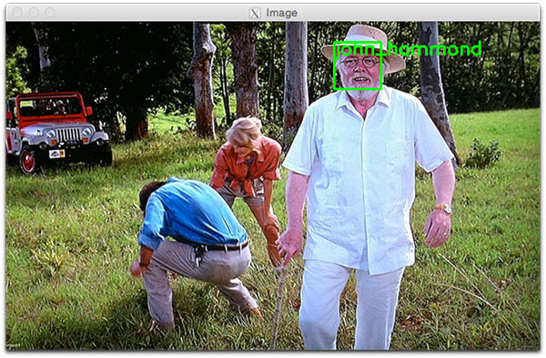

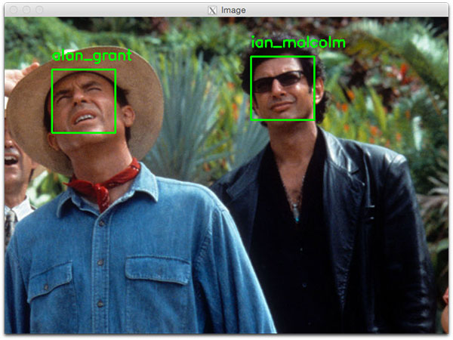

Facial Recognition Sample Outputs

**Complications**

In this project, the biggest features are the facial detection and recognition. Accounting for 100% of scenarios would mean a conclusion to this algorithm, although, in addition to these series of complex algorithms comes the fact that it must now detect and classify individuals with facial coverings. Many government officials now require the use of facial coverings when going out in public to protect everyone’s health as these masks are the best defense against Covid-19. These face masks are greatly adding consistencies to facial detection and recognition algorithm by simply blocking half of the facial features. Studies from the US National Institute of Standards and Technology (NIST) found that facial coverings cause errors and problems with algorithms identifying people. These face mask reduce the accuracy by removing most of the facial features used on facial recognition pipelines.

**Solution**

To conclude to an accurate solution, one must understand how the human brain has already solved this problem. Looking at the image below of Scarlett Johansson (left), an actress best known in big Hollywood films, and the right image where she is wearing multiple facial coverings, how can a human brain state that these two images are of one person?



Images of Celebrity

The answer is that the features outside of the facial covering area are simply still similar. When using Facial Landmarks Estimation to estimate where the face could be, the algorithm is still capable of accurately pinpointing the location of the rest of the unblocked facial features such as the eyes and chin in this case. While the method of Histogram of Oriented Gradients uses the entire features of the face based on the combinations of previous data, we can easily modify this algorithm and train it on histogram keys where some facial features are blocked by facial coverings.

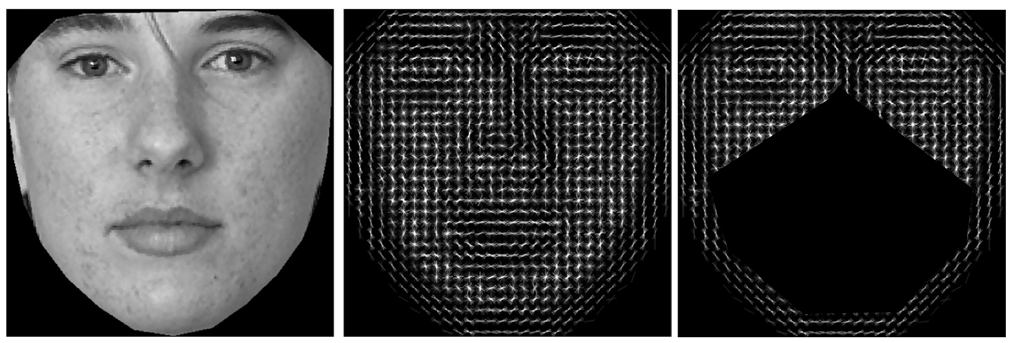

Key Formed from Histogram of Oriented Gradients

The image above displays how majority of the 128 d-embedded key has now been blocked off by a facial covering which causes majority of the misclassification.

The Facial Landmark algorithm however can be rewritten to account for the missing space caused by the facial coverings and still locate the location of the forehead, eyes, ears, and chine area. Henceforth, we can now still use the same method once it has been heavily modified to account for this change. Also, instead of using a 8x8 patch on the original image, we can easily upscale the image and still use the HOG method filters while still keeping the same 8x8 patch with minimal warping by using delicate image segmentation tools to create more “128 embeddings” of the face to account for the over 50% lost caused by the facial coverings. This method creates a vector array or key that exceeds the original amount with only slightly longer processing time. Using this method in the test shows that the machines are capable of classifying who a person might be with up to 98% accuracy only with their eyes.

Using the remainder of the 128 d-embedded key such as the face, forehead, and eyes improved the accuracy even more.

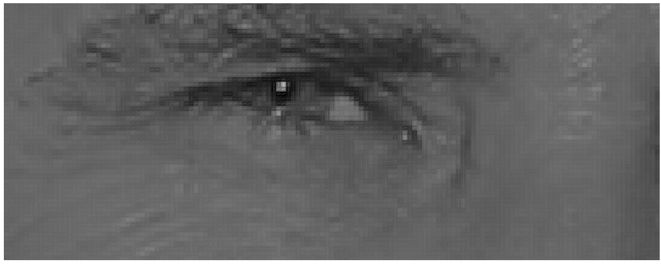

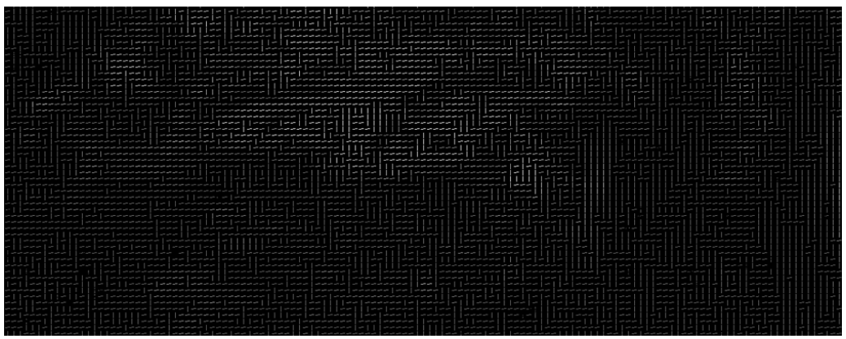

Upscaled HOG Key of Eyes

To create a pipeline that’s capable of 100% accurately detecting facial coordinates and recognition, the RCNN was also trained using synthetic data of individuals with and without facial coverings and evaluated on real images where a facial covering is present. Before creating a model of the RCN, half of the dataset were merged together with synthetic facial coverings to simulate different scenarios. Once a model is trained with the new synthetic data, the model was trained through 100 iterations and achieved a valuation accuracy of 98%.

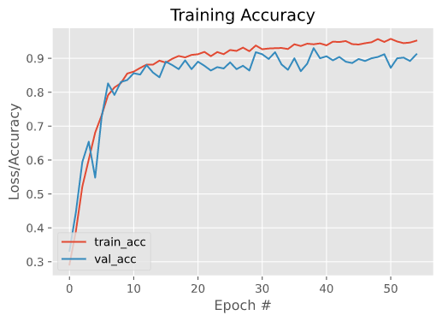

RCNN Model Training

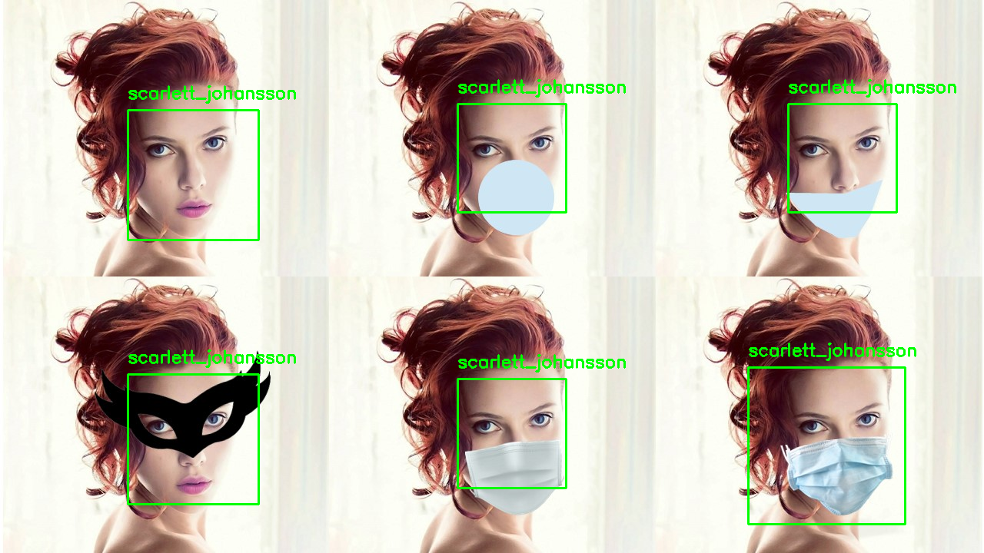

RCNN Model Prediction with Facial Coverings

By understanding the facial landmarks of a person’s face. I was able to rewrite plenty of algorithms to train on a method closed to how humans identify individuals even with face coverings on. By training a model to create different weights and classification methods on small features of the body, the model can make associations to whom the person could be just like how people identify others.

In the picture above, a heavily modified region-based convolutional neural network (mRCNN) was capable of identifying the person in less than 2 seconds. The image includes a never seen original image for the base classification and 5 different facial coverings the model has never seen before. The 2 second classification time can only be achieved by using a deep learning method running on CUDA architecture on a GPU. If this pipeline was running on just a CPU machine, the classification time is 20x-30x slower. This concludes the facial recognition pipeline.

**Webserver**

The ESP32 contains a Serial Peripheral Interface Flash File System (SPIFFS). SPIFFS is a lightweight filesystem created for microcontrollers with a flash chip, which are connected by SPI bus, like the ESP32 flash memory. In this project I upload files to the ESP32 filesystem using a plugin for Arduino IDE.

SPIFFS lets you access the flash memory like you would do in a normal filesystem in your computer, but simpler and more limited. You can read, write, close, and delete files. At the time of writing this post, SPIFFS do not support directories, so everything is saved on a flat structure.

Using SPIFFS with the ESP32 board is especially useful to:

* Create configuration files with settings.
* Save data permanently.
* Create files to save small amounts of data instead of using a microSD card.
* Save HTML and CSS files to build a web server.
* Save images, figures, and icons.

To make the webserver simpler, we can write it in HTML and CSS. Because with SPIFFS, you can write the HTML and CSS in a separated file and save them on the ESP32 filesystem to run without external resources.

After uploading the HTML, CSS, AND JAVASCRIPT files to the ESP32 using a filesystem uploader, our ESP32 can run the webserver with the embedded website on sole power and Wi-Fi.

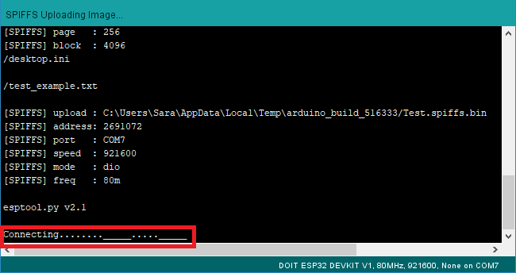

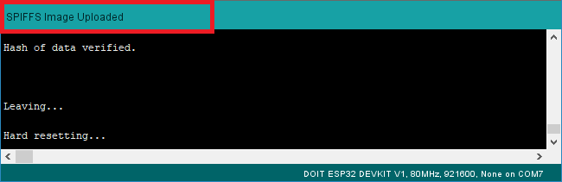

After wards, we upload the webserver code to our device to make the ESP32 a stand-alone webserver accessible by an IP address (because publishing and getting a public would cost money or will have to use a 3rd party once again causing problems to our data transfer).

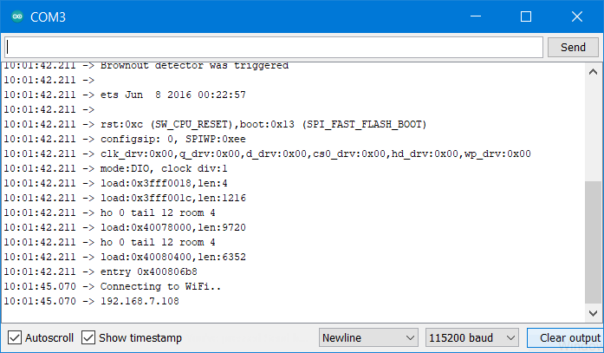

After wards, we upload the webserver code to our device to make the ESP32 a stand-alone webserver accessible

**System Software Architecture**

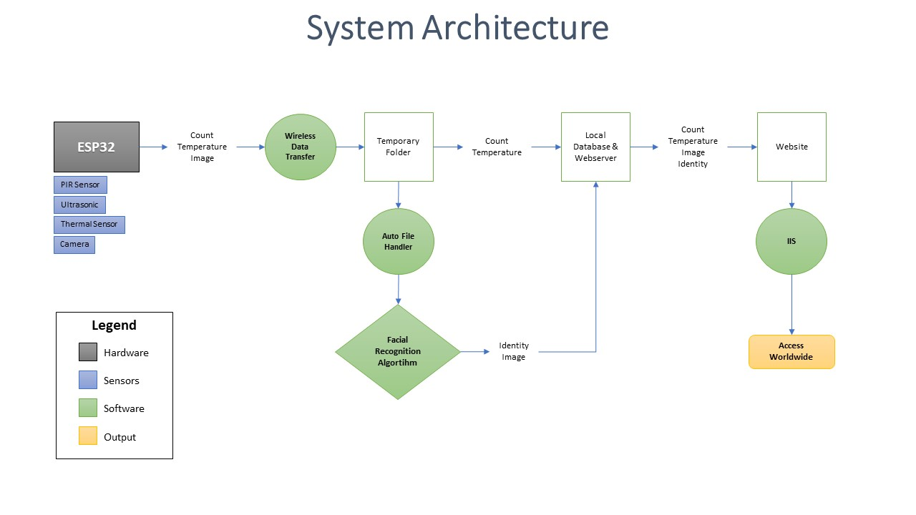

The software is comprised of the green nodes. Since the Facial Recognition, Webserver, and the Websites were completed, the next step was to create a Database that is capable of connecting all the software together.



Database

For the sake of time and simple integration, a local database was configured using PHP for SQL server. This way, we can easily configure the webserver locally and host the website in a local computer. With this database, we can input all the data from the ESP32 here and output all results with HTML scripts into the website.

Once a database was completed, we now need a program that can automatically handle files. This handler or “brain” should be capable of taking the input files from the ESP32, run the facial recognition algorithm on the images, and update the rest of the information together to be displayed to the website.

For this handler, I used a Python API to monitor file system events for the database. This was applied by using a simple modified FIFO queue technique. Which means, that if the files being monitored have new items created, the observer can enqueue the file name, location, and type being inputted into the database’s monitored folders and do what the users specify instructions based on file types. For this case, the system handler monitors a folder where the data is being inputted into, then if the file type is that of an image (.jpg), it will run the facial recognition software automatically and outputs the identity of a person in the image into the database. Whereas if the file type is that of an excel documents (.cv2 or .xlsx), it will then update the database info with the new inputs from the ESP32.



System Handler

As a simple demonstration, the top left folder called “temp” is a temporary folder where new data inputted in. When the system handler, on the right, detects a new item in the “temp” folder, it will then automatically run the facial detection algorithm and outputs the results in the database on the bottom left side.

To conclude, the system handler acts as the “brain” of the entire software to integrate all parts together taking inputs and getting necessary outputs. The system handler only has an execution time of just over 1 second to classify identities and outputs into the website.

Finally, now that all the software nodes are integrated together, the website should then be accessible worldwide in any devices.

For this, I use an IIS (Internet Information Services). IIS runs in the Microsoft.NET platform on the Windows OS. The IIS acts as the webserver for hosting out HTML web application. The IIS handles all the request using a request-response pattern, where a Client sends a request to the webserver and receive back with the HTTP. With this, we can easily host a website that can be accessed anywhere in the world with a simple IP address.



Website Accessed Worldwide

[1] O. M. Parkhi, A. Vedaldi, A. Zisserman Deep Face Recognition British Machine Vision Conference, 2015.

[2] H.-W. Ng, S. Winkler. A data-driven approach to cleaning large face datasets. Proc. IEEE International Conference on Image Processing (ICIP), Paris, France, Oct. 27-30, 2014.

[3] A. Geitgey, “Machine Learning is Fun! Part 4: Modern Face Recognition with Deep Learning,” Medium, 24-Sep-2020.

[4] J.R.R. Uijlings, K.E.A. van de Sande, T. Gevers, A.W.M. Smeulders. Selective Search for Object Recognition, University of Trento, Italy and University of Amsterdam, Netherlands 2012.